Name: Maloth Aditya
Roll No: 120CS0124

MANET

CODE:
/* -*- Mode: C++; c-file-style: "gnu"; indent-tabs-mode:nil; -*- */
/*
* Copyright (c) 2011 University of Kansas
*
* This program is free software; you can redistribute it and/or modify
* it under the terms of the GNU General Public License version 2 as
* published by the Free Software Foundation;
*
* This program is distributed in the hope that it will be useful,
* but WITHOUT ANY WARRANTY; without even the implied warranty of
* MERCHANTABILITY or FITNESS FOR A PARTICULAR PURPOSE. See the
* GNU General Public License for more details.
*
* You should have received a copy of the GNU General Public License
* along with this program; if not, write to the Free Software
* Foundation, Inc., 59 Temple Place, Suite 330, Boston, MA 02111-1307 USA
*
* Author: Justin Rohrer <rohrej@ittc.ku.edu>
*
* James P.G. Sterbenz <jpgs@ittc.ku.edu>, director
* ResiliNets Research Group http://wiki.ittc.ku.edu/resilinets
* Information and Telecommunication Technology Center (ITTC)
* and Department of Electrical Engineering and Computer Science
* The University of Kansas Lawrence, KS USA.
*
* Work supported in part by NSF FIND (Future Internet Design) Program
* under grant CNS-0626918 (Postmodern Internet Architecture),
* NSF grant CNS-1050226 (Multilayer Network Resilience Analysis and Experimentation on GENI),
* US Department of Defense (DoD), and ITTC at The University of Kansas.
*/

/*
* This example program allows one to run ns-3 DSDV, AODV, or OLSR under
* a typical random waypoint mobility model.
*
* By default, the simulation runs for 200 simulated seconds, of which
* the first 50 are used for start-up time. The number of nodes is 50.
* Nodes move according to RandomWaypointMobilityModel with a speed of
* 20 m/s and no pause time within a 300x1500 m region. The WiFi is
* in ad hoc mode with a 2 Mb/s rate (802.11b) and a Friis loss model.
* The transmit power is set to 7.5 dBm.
*
* It is possible to change the mobility and density of the network by
* directly modifying the speed and the number of nodes. It is also
* possible to change the characteristics of the network by changing
* the transmit power (as power increases, the impact of mobility
* decreases and the effective density increases).
*
* By default, OLSR is used, but specifying a value of 2 for the protocol
* will cause AODV to be used, and specifying a value of 3 will cause
* DSDV to be used.
*
* By default, there are 10 source/sink data pairs sending UDP data
* at an application rate of 2.048 Kb/s each. This is typically done
* at a rate of 4 64-byte packets per second. Application data is
* started at a random time between 50 and 51 seconds and continues
* to the end of the simulation.
*
* The program outputs a few items:
* - packet receptions are notified to stdout such as:
* <timestamp> <node-id> received one packet from <src-address>
* - each second, the data reception statistics are tabulated and output
* to a comma-separated value (csv) file
* - some tracing and flow monitor configuration that used to work is
* left commented inline in the program
*/

#include <fstream>
#include <iostream>
#include "ns3/core-module.h"
#include "ns3/network-module.h"
#include "ns3/internet-module.h"
#include "ns3/mobility-module.h"
#include "ns3/aodv-module.h"
#include "ns3/olsr-module.h"
#include "ns3/dsdv-module.h"
#include "ns3/dsr-module.h"
#include "ns3/applications-module.h"
#include "ns3/yans-wifi-helper.h"
#include "ns3/flow-monitor.h"
#include "ns3/flow-monitor-helper.h"

using namespace ns3;
using namespace dsr;

NS_LOG_COMPONENT_DEFINE ("manet-routing-compare");

class RoutingExperiment
{
public:
RoutingExperiment ();
void Run (int nSinks, double txp, std::string CSVfileName);
//static void SetMACParam (ns3::NetDeviceContainer & devices,
// int slotDistance);
std::string CommandSetup (int argc, char **argv);

private:
Ptr<Socket> SetupPacketReceive (Ipv4Address addr, Ptr<Node> node);
void ReceivePacket (Ptr<Socket> socket);
void CheckThroughput ();

uint32_t port;
uint32_t bytesTotal;
uint32_t packetsReceived;

std::string m_CSVfileName;
int m_nSinks;
std::string m_protocolName;
double m_txp;
bool m_traceMobility;
uint32_t m_protocol;
};

RoutingExperiment::RoutingExperiment ()
: port (9),
bytesTotal (0),
packetsReceived (0),
m_CSVfileName ("manet-routing.output.csv"),
m_traceMobility (false),
m_protocol (2) // AODV
{
}

static inline std::string
PrintReceivedPacket (Ptr<Socket> socket, Ptr<Packet> packet, Address senderAddress)
{
std::ostringstream oss;

oss << Simulator::Now ().GetSeconds () << " " << socket->GetNode ()->GetId ();

if (InetSocketAddress::IsMatchingType (senderAddress))
{
InetSocketAddress addr = InetSocketAddress::ConvertFrom (senderAddress);
oss << " received one packet from " << addr.GetIpv4 ();
}
else
{
oss << " received one packet!";
}
return oss.str ();
}

void
RoutingExperiment::ReceivePacket (Ptr<Socket> socket)
{
Ptr<Packet> packet;
Address senderAddress;
while ((packet = socket->RecvFrom (senderAddress)))
{
bytesTotal += packet->GetSize ();
packetsReceived += 1;
NS_LOG_UNCOND (PrintReceivedPacket (socket, packet, senderAddress));
}
}

void
RoutingExperiment::CheckThroughput ()
{
double kbs = (bytesTotal * 8.0) / 1000;
bytesTotal = 0;

std::ofstream out (m_CSVfileName.c_str (), std::ios::app);

out << (Simulator::Now ()).GetSeconds () << ","
<< kbs << ","
<< packetsReceived << ","
<< m_nSinks << ","
<< m_protocolName << ","
<< m_txp << ""
<< std::endl;

out.close ();
packetsReceived = 0;
Simulator::Schedule (Seconds (1.0), &RoutingExperiment::CheckThroughput, this);
}

Ptr<Socket>
RoutingExperiment::SetupPacketReceive (Ipv4Address addr, Ptr<Node> node)
{
TypeId tid = TypeId::LookupByName ("ns3::UdpSocketFactory");
Ptr<Socket> sink = Socket::CreateSocket (node, tid);
InetSocketAddress local = InetSocketAddress (addr, port);
sink->Bind (local);
sink->SetRecvCallback (MakeCallback (&RoutingExperiment::ReceivePacket, this));

return sink;
}

std::string
RoutingExperiment::CommandSetup (int argc, char **argv)
{
CommandLine cmd (__FILE__);
cmd.AddValue ("CSVfileName", "The name of the CSV output file name", m_CSVfileName);
cmd.AddValue ("traceMobility", "Enable mobility tracing", m_traceMobility);
cmd.AddValue ("protocol", "1=OLSR;2=AODV;3=DSDV;4=DSR", m_protocol);
cmd.Parse (argc, argv);
return m_CSVfileName;
}

int
main (int argc, char *argv[])
{
RoutingExperiment experiment;
std::string CSVfileName = experiment.CommandSetup (argc,argv);

//blank out the last output file and write the column headers
std::ofstream out (CSVfileName.c_str ());
out << "SimulationSecond," <<
"ReceiveRate," <<
"PacketsReceived," <<
"NumberOfSinks," <<
"RoutingProtocol," <<
"TransmissionPower" <<
std::endl;
out.close ();

int nSinks = 10;
double txp = 7.5;

experiment.Run (nSinks, txp, CSVfileName);
}

void
RoutingExperiment::Run (int nSinks, double txp, std::string CSVfileName)
{
//CommandLine cmd;
//cmd.AddValue("CSVfileName","The name of the CSV output file name", m_CSVfileName);
//cmd.AddValue("traceMobility","Enable mobility tracing", m_traceMobility);
//cmd.AddValue("protocol", "1=OLSR;2=AODV;3=DSDV;4=DSR", m_protocol);
Packet::EnablePrinting ();
m_nSinks = nSinks;
m_txp = txp;
m_CSVfileName = CSVfileName;

int nWifis = 50;

double TotalTime = 200.0;
std::string rate ("2048bps");
std::string phyMode ("DsssRate11Mbps");
std::string tr_name ("manet-routing-compare");
int nodeSpeed = 20; //in m/s
int nodePause = 0; //in s
m_protocolName = "protocol";

Config::SetDefault ("ns3::OnOffApplication::PacketSize",StringValue ("64"));
Config::SetDefault ("ns3::OnOffApplication::DataRate", StringValue (rate));

//Set Non-unicastMode rate to unicast mode
Config::SetDefault ("ns3::WifiRemoteStationManager::NonUnicastMode",StringValue (phyMode));

NodeContainer adhocNodes;
adhocNodes.Create (nWifis);

// setting up wifi phy and channel using helpers
WifiHelper wifi;
wifi.SetStandard (WIFI_STANDARD_80211b);

YansWifiPhyHelper wifiPhy;
YansWifiChannelHelper wifiChannel;
wifiChannel.SetPropagationDelay ("ns3::ConstantSpeedPropagationDelayModel");
wifiChannel.AddPropagationLoss ("ns3::FriisPropagationLossModel");
wifiPhy.SetChannel (wifiChannel.Create ());

// Add a mac and disable rate control
WifiMacHelper wifiMac;
wifi.SetRemoteStationManager ("ns3::ConstantRateWifiManager",
"DataMode",StringValue (phyMode),
"ControlMode",StringValue (phyMode));

wifiPhy.Set ("TxPowerStart",DoubleValue (txp));
wifiPhy.Set ("TxPowerEnd", DoubleValue (txp));

wifiMac.SetType ("ns3::AdhocWifiMac");
NetDeviceContainer adhocDevices = wifi.Install (wifiPhy, wifiMac, adhocNodes);

MobilityHelper mobilityAdhoc;
int64_t streamIndex = 0; // used to get consistent mobility across scenarios

ObjectFactory pos;
pos.SetTypeId ("ns3::RandomRectanglePositionAllocator");
pos.Set ("X", StringValue ("ns3::UniformRandomVariable[Min=0.0|Max=300.0]"));
pos.Set ("Y", StringValue ("ns3::UniformRandomVariable[Min=0.0|Max=1500.0]"));

Ptr<PositionAllocator> taPositionAlloc = pos.Create ()->GetObject<PositionAllocator> ();
streamIndex += taPositionAlloc->AssignStreams (streamIndex);

std::stringstream ssSpeed;
ssSpeed << "ns3::UniformRandomVariable[Min=0.0|Max=" << nodeSpeed << "]";
std::stringstream ssPause;
ssPause << "ns3::ConstantRandomVariable[Constant=" << nodePause << "]";
mobilityAdhoc.SetMobilityModel ("ns3::RandomWaypointMobilityModel",
"Speed", StringValue (ssSpeed.str ()),
"Pause", StringValue (ssPause.str ()),
"PositionAllocator", PointerValue (taPositionAlloc));
mobilityAdhoc.SetPositionAllocator (taPositionAlloc);
mobilityAdhoc.Install (adhocNodes);
streamIndex += mobilityAdhoc.AssignStreams (adhocNodes, streamIndex);
NS_UNUSED (streamIndex); // From this point, streamIndex is unused

AodvHelper aodv;
OlsrHelper olsr;
DsdvHelper dsdv;
DsrHelper dsr;
DsrMainHelper dsrMain;
Ipv4ListRoutingHelper list;
InternetStackHelper internet;

switch (m_protocol)
{
case 1:
list.Add (olsr, 100);
m_protocolName = "OLSR";
break;
case 2:
list.Add (aodv, 100);
m_protocolName = "AODV";
break;
case 3:
list.Add (dsdv, 100);
m_protocolName = "DSDV";
break;
case 4:
m_protocolName = "DSR";
break;
default:
NS_FATAL_ERROR ("No such protocol:" << m_protocol);
}

if (m_protocol < 4)
{
internet.SetRoutingHelper (list);
internet.Install (adhocNodes);
}
else if (m_protocol == 4)
{
internet.Install (adhocNodes);
dsrMain.Install (dsr, adhocNodes);
}

NS_LOG_INFO ("assigning ip address");

Ipv4AddressHelper addressAdhoc;
addressAdhoc.SetBase ("10.1.1.0", "255.255.255.0");
Ipv4InterfaceContainer adhocInterfaces;
adhocInterfaces = addressAdhoc.Assign (adhocDevices);

OnOffHelper onoff1 ("ns3::UdpSocketFactory",Address ());
onoff1.SetAttribute ("OnTime", StringValue ("ns3::ConstantRandomVariable[Constant=1.0]"));
onoff1.SetAttribute ("OffTime", StringValue ("ns3::ConstantRandomVariable[Constant=0.0]"));

for (int i = 0; i < nSinks; i++)
{
Ptr<Socket> sink = SetupPacketReceive (adhocInterfaces.GetAddress (i), adhocNodes.Get (i));

AddressValue remoteAddress (InetSocketAddress (adhocInterfaces.GetAddress (i), port));
onoff1.SetAttribute ("Remote", remoteAddress);

Ptr<UniformRandomVariable> var = CreateObject<UniformRandomVariable> ();
ApplicationContainer temp = onoff1.Install (adhocNodes.Get (i + nSinks));
temp.Start (Seconds (var->GetValue (100.0,101.0)));
temp.Stop (Seconds (TotalTime));
}

std::stringstream ss;
ss << nWifis;
std::string nodes = ss.str ();

std::stringstream ss2;
ss2 << nodeSpeed;
std::string sNodeSpeed = ss2.str ();

std::stringstream ss3;
ss3 << nodePause;
std::string sNodePause = ss3.str ();

std::stringstream ss4;
ss4 << rate;
std::string sRate = ss4.str ();

//NS_LOG_INFO ("Configure Tracing.");
//tr_name = tr_name + "_" + m_protocolName +"_" + nodes + "nodes_" + sNodeSpeed + "speed_" + sNodePause + "pause_" + sRate + "rate";

//AsciiTraceHelper ascii;
//Ptr<OutputStreamWrapper> osw = ascii.CreateFileStream ( (tr_name + ".tr").c_str());
//wifiPhy.EnableAsciiAll (osw);
AsciiTraceHelper ascii;
//MobilityHelper::EnableAsciiAll (ascii.CreateFileStream (tr_name + ".mob"));
MobilityHelper::EnableAsciiAll (ascii.CreateFileStream ("lab7.tr"));

Ptr<FlowMonitor> flowmon;
FlowMonitorHelper flowmonHelper;
flowmon = flowmonHelper.InstallAll ();

NS_LOG_INFO ("Run Simulation.");

CheckThroughput ();

Simulator::Stop (Seconds (TotalTime));
Simulator::Run ();

flowmon->SerializeToXmlFile ((tr_name + ".flowmon").c_str(), false, false);

Simulator::Destroy ();
}

OUTPUT:

a. Receive Rate
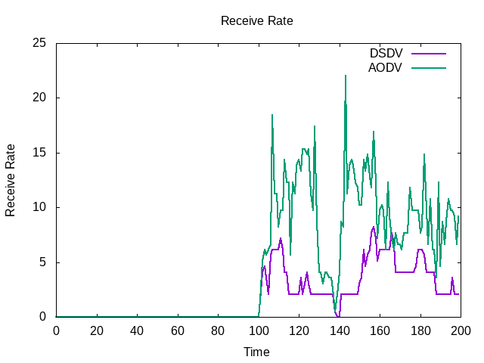

b. Packets Received
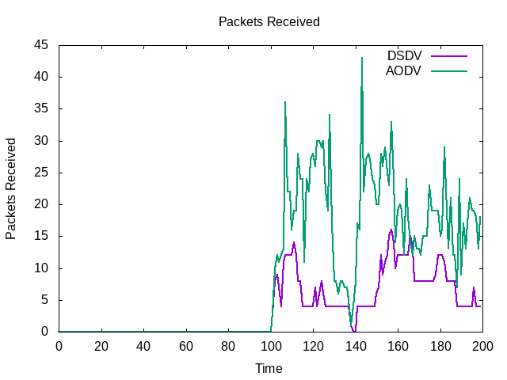
Based on the above observations, it is concluded that AODV is the best protocol.

